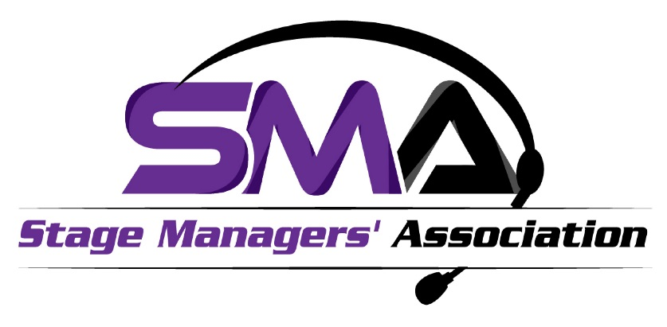

October 10th, 2024

**For Immediate Release:**

**The Stage Managers’ Association Announces 2024**

**Del Hughes Awards**

**for Lifetime Achievement in the Art of Stage Management**

**Virtual Event Tickets Now Available**

On Monday October 28th, 2024, the Stage Managers’ Association (SMA) will present its annual Del Hughes Awards for Lifetime Achievement in the Art of Stage Management, at the National Opera Center’s Marc A. Scorca Hall in NYC. The distinguished 2024 honorees are theatrical Production Stage Managers Lloyd Davis, Jr., Ed De Shae, and Denise Yaney. In addition to these Lifetime Achievement Awards, the SMA will honor Mary Hunter with The Founders Award for her careers both in Stage Management and as a leading educator. This year’s Special Recognition Award will shine the spotlight on David J. McGraw and The Stage Manager Survey.

The Del Hughes honor is awarded to those who represent the finest qualities and artistic achievement in stage management throughout their lifelong career. Instituted in 1986, the award was named for Del Hughes, who had an illustrious career as a Broadway and television stage manager as well as a TV director from 1933 to the 1970s.  Honorees are chosen each February from nominations submitted by industry members.

Adrienne Wells, Chair of the Stage Managers’ Association, states "In all of the entertainment industry's many segments, Stage Managers have a positive impact on every production they work on. Their day-to-day work is critical to the smooth running and successful artistic execution of a show but is often unseen by most people. It continues to be our honor to publicly recognize the amazing skill and artistry that Del Hughes Award recipients have brought to their careers. Additionally, through the outstanding achievements of this year's Founders Award and Special Recognition Award recipients we continue to advance the next generation of Stage Managers and our knowledge of the Stage Management Industry."

Del Hughes honoree **Ed De Shae** reflects “I pay homage to the dreams & aspirations of those upon whose shoulders I stand. My mission has primarily been to the service of the American Black Theatre Movement and expanded to include the World Stage. Theatre is a labor of love! Gibran said of love, "Think not that you can guide the course of love... For love, if it finds you worthy shall guide your course."

Taking in this moment, Del Hughes honoree **Lloyd Davis, Jr.** speaks to mentorship, “Two things I always emphasized to my mentees were: The need to fully understand that stage managers are the *artistic catalysts* in the rehearsal process.  Our organizational and communication skills are essential in setting up a safe environment in the rehearsal room for the actor to “sail or fail". Along with, “Every stage manager should take at least one acting class.  You are on that stage as much as every actor is when you are calling a show in performance.  Understanding the mindset of the actor is vital in the timing and execution of cues and the smooth running of the show.” During Lloyd’s early career, his “…only mission when I moved to NYC, as a wide-eyed college grad full of dreams was, “Broadway in 10 years or bust!”.   But I realized shortly after moving to NYC that Broadway wasn't the brass ring.  The exciting, challenging work, and the real art, was happening Off and Off Off Broadway. It was the ’70’s and a magical time to be in NYC theatre.  I was here and in the throes of it all.  Mission accomplished!”

This year, with Del Hughes honoree **Denise Yaney’s** prolific career-long role as a Broadway Assistant Stage Manager, the SMA celebrates the position of the Assistant Stage Manager. In speaking personally about the future of our industry, Denise expressed, “Computing and cell phones are here to stay. They help with tasks and communication is instantaneous, but I would hope for a return to a rehearsal room where a mug of pencils, a sharpener and a box of Kleenex are all that’s on the stage manager’s table and not a bank of opened laptops separating me from the actors and their creative process and the actors from their creative partners.”

**Mary Hunter**, being honored with The Founders Award shares, her “impacts are not for me to site but rather they are reflected in the results of one’s work and/or the experiences of your colleagues or students. At Yale, to heighten the profile and respect for Stage Managers and to give more definition and understanding as to the practice of stage management, I worked to establish the Department of Stage Management rather than it being a program within another department at the school.” Throughout her career she “simply wanted to work with the highest caliber of theatre artists and artisans at large, artistically varied, and financially supported regional theatres around the country. While in school, I sent out one resume to The Guthrie Theatre, got an internship in the scene shop, and never looked back. My career path consisted of timing, reputation, a willingness to travel and an eagerness to take on any challenge.”

On receiving the Special Recognition Award, **David J. McGraw** states, “The Stage Manager Survey is only as strong as the number and range of stage managers who participate.  The SMA has championed the survey since its beginnings and this award will provide even more visibility as the survey continues to grow.” Reflecting on the impact on our industry, “While it has been wonderful to have the Stage Manager Survey cited in other studies and publications, what is most rewarding is hearing from working stage managers what the survey has meant to them.  Stage Management is an isolated profession, so it can be very reassuring to see that there are others facing the same challenges as ourselves.”

Cheryl Mintz and Matthew Stern, Chairs of the Del Hughes Event and Directors-at-Large of the Stage Managers’ Association, are pleased to announce the guest speakers at the event, which include Broadway Production Stage Manager and past Del Hughes Award honoree Roy Harris, Broadway Production Stage Manager Diane DiVita, Artistic Director, Director & Actor William Carden, and Choreographer Yvonne Curry. SMA Chair Adrienne Wells will give the keynote. John M. Atherlay will speak on behalf of the Stage Managers’ Association Foundation. The hosts of the event are Cheryl Mintz, and past Special Recognition Honoree Narda E. Alcorn. The SMA thanks Broadway Cares/Equity Fights AIDS for their leading sponsorship of the event.

The event is available virtually on Monday, October 28th, 2024 at 7:30pm ET/4:30pm PT. Registration is required and the event is free. Go to <https://SMADH2024.eventbrite.com> to register.

To join the SMA go to [www.stagemanagers.org](http://www.stagemanagers.org)

**About the Stage Managers’ Association**

The Stage Managers’ Association of the United States (SMA) is the only professional organization for working stage managers across the United States. Our mission is to recognize, advocate for, and provide continuing education and networking opportunities, creating community for stage managers across the USA and connecting them with the world through our International Cohort.

Celebrating our 42nd anniversary, the Stage Managers’ Association is a pivotal resource for stage managers nationwide in all areas of live performance. With a growing national membership, the SMA promotes networking opportunities through our many initiatives such as Operation Observation, Collaborative Connections, and A View from the Wings Symposia. SMA members include top Broadway, Off Broadway, Corporate, Regional, Dance, and Opera stage managers as well as students and those just beginning their careers.

The Stage Managers’ Association strives for equity, fairness, diversity and inclusion. As stage managers we are discreet in our dealings with Productions, Producers and employers. We respect and value diverse life experiences and heritages, strive toward equitable treatment of our members, and support members who nurture diversity and equity in their places of work and in their broader communities.

Learn more about the Stage Managers’ Association at [www.stagemanagers.org](http://www.stagemanagers.org/)

Stage Managers’ Association

The Del Hughes Award, The Founders Award & Special Recognition Honorees 2024

The Del Hughes Honorees Lloyd Davis, Jr., Ed De Shae, Denise Yaney

The Founders Award Honoree Mary Hunter,

Special Recognition Award Honoree David J. McGraw and The Stage Manager Survey

_________________________________________________________

Press & Event Questions please contact:

Cheryl Mintz

Del Hughes Award Event Chair

Stage Managers’ Association

[cherylgaymintz@gmail.com](mailto:cherylgaymintz@gmail.com)

________________________________________________________

**Stage Managers’ Association Board of Directors**

**OFFICERS**

Chair – Adrienne Wells

Vice Chair – Alfredo (Fredo) Aguilar

Treasurer - Amy Paige

Corresponding Secretary – Renee Dessommes

Interim Recording Secretary – Brian Rangell

Editor in Chief - Hope Rose Kelly

Director of Education - Amanda Spooner

Past Chair – Elynmarie Kazle

**DIRECTORS AT LARGE**

Katrina Herrmann

Suzi Kilbourne

R. Christopher Maxwell

Cheryl Mintz

Casey Sammarco

Matthew Aaron Stern

**REGIONAL DIRECTORS**

Renee Yancey, East

Maegan Burnell, Central

Rusty Cloyes, West

Betsy Paull-Rick, West

James Latus, NY Metro

Rachel Zucker, NY Metro